**Chocoholics Anonymous**



***Use Case Summary Document***

**Version No. 2.0**

**Project Document Revision History**

|  |  |  |  |
| --- | --- | --- | --- |
| **VersionNumber** | **Date** | **Revision Author** | **Description of Revision** |
| 1.0 | 05/30/2019 | She-Wolverines | Initial Version of Business use case |
| 1.0 | 07/14/2019 | The Best and the Brightest | July Revision |

|  |
| --- |
| **Table of Contents** |

Introduction **4**

Project/Application Actors **5**

Use Case List **5**

Use Case Diagram(s) **6**

Use Case Summary **7**

Use Case Summary Review and Signoff **10**

# **Introduction**

Chocoholics Anonymous (ChocoAn) is an organization that provides help to people who are addicted to chocolate. ChocoAn has associations with healthcare professionals( providers )to provide consultation or treatments to its members. A new member will register with the ChocAn organization to take the services.

Providers after providing the services to the members, can swipe the members card, enter member details, provider details, service details and bill the chocAn. Provider can gather weekly bills and ChocAn will make payment to the provider based on the services and number of services that each provider had served for a particular week. The EFT will transfer the funds to the provider.

The ChocoAn DataCenter System is the main software that keeps the record for all the providers and members like validating a member’s status and providing service fees and code to the provider. It is used to generate different reports every friday midnight or on demand by the ChocoAn Manager. A provider Report is generated which contains a list of all the services provided by that specific provider during that week. A member report is generated which shows a list of services taken by that specific member during the week. A summary report is sent to the manager for accounts payable, it lists all the providers who are to be paid for that week , the total no of consultations and total fee to be paid. All these reports are sent in the form of email attachment. The ChocoAn DataCenter is used by the operator to modify the records for members and providers.

The processing of payments of ChocAn membership fees has been contracted out to Acme Accounting Services(AAS), a third-party organization. The AAS updates the ChocAn DataCenter with membership records every evening at 9 P.M.

The provider can request for the provider directory from the data center/System anytime to refer to the existing service codes and any new added service.

# **Project/Application Actors**

An actor is someone or something (e.g. application system) outside the system or business that interacts with the application.

|  |  |
| --- | --- |
| **Actor Name** | **Description** |
| AAS | ACME accounting service is a third party vendor who manages the member fee and status. |
| EFT | EFT is a third party vendor which transfers money to the providers. |
| Manager | Manager is a ChocAn employe who manages the other employees. |
| Member | A member is one who joins the ChocAn to get the services for removing their chocolate addiction. |
| Operator | Operator is the an ChocAn employee who logins in to the terminal. Also known as a Provider |
| Provider/Operator | Provider is a ChocAn Employee who provides services to the members. |
| System | ChocoAn Data Center system is a utility which stores service, consultation, member and provider details. |
| Time | Reports are generated at a specific time , also the payment process is triggered at a certain time |

# **Use Case List**

1. Manage ~~Registration~~ Members
2. Provider Payment
3. Member Payment
4. Report Extraction
5. ~~Provide~~ Track Service
6. Manage Providers

# **Use Case Diagram(s)**

[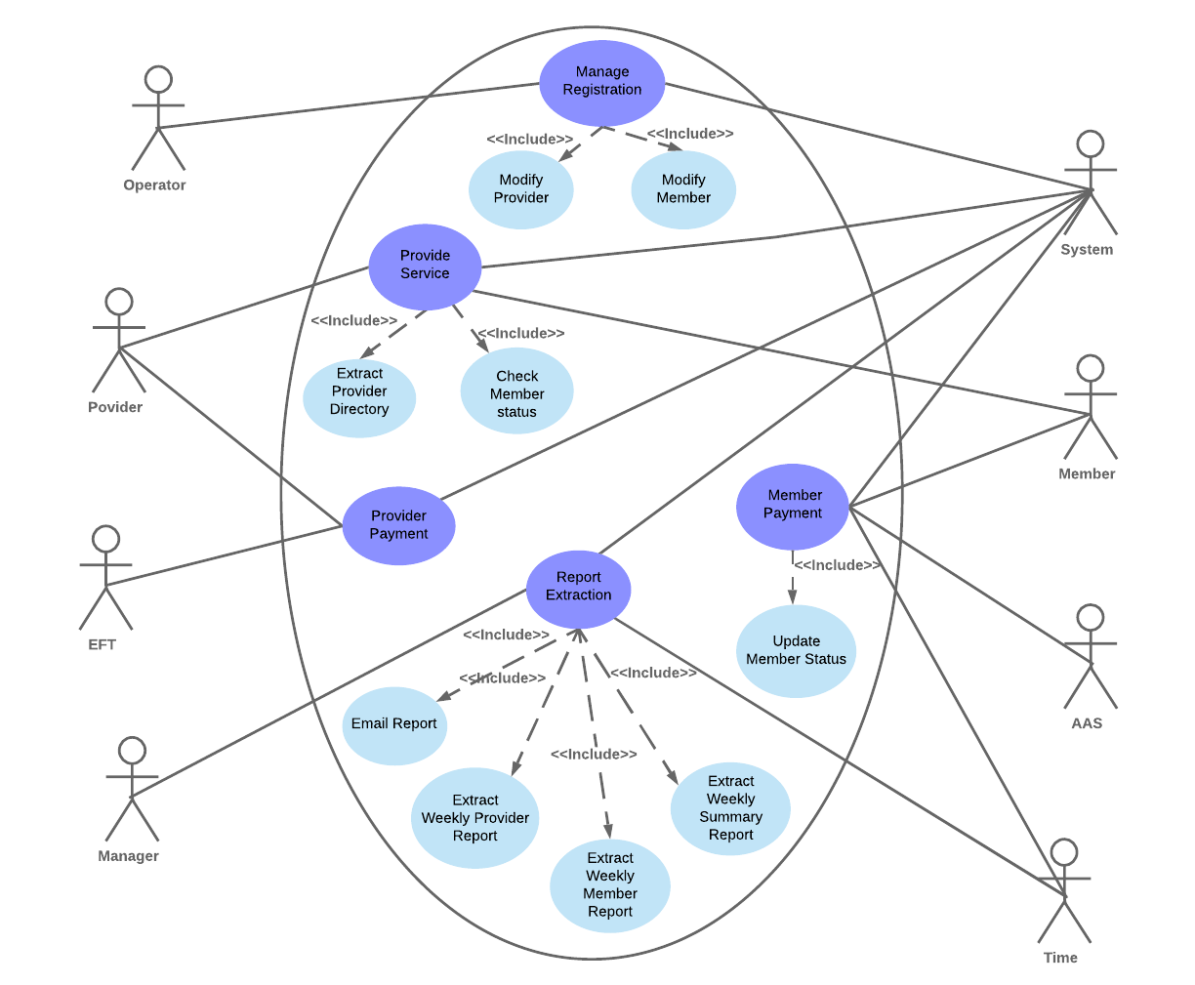](https://www.lucidchart.com/documents/edit/e4225d2b-b20f-493c-a91c-d3968eedc8df/0?callback=close&name=docs&callback_type=back&v=2008&s=612)

# Use Case Summary

Below is the list of use-cases and a brief introduction about them :

1. **Manage ~~Registration~~ Members -** Chocoholics Anonymous provides health services to the chocolate addicts.To receive/provide services from/to ChocAn, a member~~/provider~~ must be registered with the System and the managing of the records will be done by the operator.To receive the health services from ChocAn the member has to provide his/her details to ~~the~~ the Operator~~,~~. Then the operator will add the new member to the system. ~~Similarly, Operator will add a new provider to the system after receiving details from the provider.~~ Whenever there is a change in the details like address, email id, phone, then the member~~/provider~~ will give the updated details to the operator, and the operator will update the ~~provider/~~member details in the system.Operator can also delete the existing member~~/provider~~ from the ChocAn System.

**Primary Actor** - System, Operator

**Secondary actor** - Member~~, Provider~~

**Use Case diagram number and reference** - [01 Manage Registration](https://docs.google.com/document/d/1HuuiE7o1EBV8ugt4rViox9uOCa43eWewJgUaV5uxfIo/edit#)

1. **Provider Payment -** Every week based on the total number and type of services performed, the ChocAn provider receives payments. The ChocAn Data enter writes records of these amounts to a disk which then is read by the EFT component. This action initiates EFT money transfers to providers’ respective accounts. ~~The ChocAn provider gets weekly payment of amount calculated by the total number and type of services he/she has performed for the week. The Chocoholics Anonymous Data center write the record of all the providers payments details for the week on the disk, the EFT component then reads that data from the disk and initiate an EFT money transfer to credit the providers account respectively.~~

**Primary Actor** - EFT, Time

**Secondary actor** - Provider, System

**Use Case diagram number and reference** - [02 Provider Payment](https://docs.google.com/document/d/19AFmTMdqTCmDWS9KM1JqdBJu3nqXWBaJ2cotLJFy-A8/edit#heading=h.mkdpts1oj67d)

1. **Member Payment** - ChocAn members pay monthly fees to ChocAn. For this fee, members are eligible to receive unlimited consultations and treatments with health care professionals. If a member is owed for a month or more, membership updated. To receive health care services from ChocAn, the member hands his or her card to the provider, who slides the card through the card reader on the terminal. The terminal then dials the ChocAn Data Center, and the ChocAn Data Center computer verifies the member number. If the number is valid, the word Validated appears on the one-line display. If the number is not valid, the reason is displayed as Member suspended. This message indicates that fees are owed (that is, the member has not paid membership fees for at least a month) and member status has been set to suspended.

**Primary Actor :** Member , AAS, Time

**Secondary Actor :** System

**Use Case diagram number and reference** - [03 MemberPayment](https://docs.google.com/document/d/1LwxO9y6RY-4qx-AVzfKOT4lV76bVAHcpX2WiRaOuCOA/edit#heading=h.mkdpts1oj67d)

1. **Report Extraction** - Every Friday at 12:00am numerous reports are generated and sent out to members, providers, and the manager.   
    The manager can request the summary report at any time from the data center services. The manager’s summary report contains a list of all the providers to be paid, number of consultations each had, and his or her total fee for that week. ~~the total fee for the specific week.~~ The report should also contain information on the total number of providers who provided services, the total number of consultations, and the total fee to be paid.   
    Each provider who has billed ChocAn during that week receives a report via email for the list of services provided by them to ChocAn members and the weekly fees. The report should also contain the total number of consultations with members and the total fee for the given week.   
    Each member who has consulted a ChocAn provider during that week will receive a report having details about the weekly services they received and ~~also~~ the total cost of the services rendered through email. ~~The reports are emailed to provider and member every week.~~

**Primary Actor :** System, Manager

**Secondary actor :** Provider, Member, ~~and~~ Time

**Use Case Diagram number and reference -** [04 Extract Report](https://docs.google.com/document/d/1ZAiJBcV_n_8zWkMUhoGFMlgu1qHoFQ8s/edit#bookmark=id.bm27amgg1es6)

1. **~~Provide Service -~~** ~~Members swipe the card or enter member number to receive the services.The Provider provides services to the Members. After providing the services to the members, the Provider will again swipe the members card, enter member details, provider details, service details and bill the chocAn. ChocAn will make payment to the provider based on the services and number of services that each provider had served for a particular week.~~

**~~Primary Actor :~~** ~~Provider, Member ,System~~

**~~Secondary Actor :~~** ~~None~~

1. **Track Service -** When a member's card is swiped for a service that is being provided the system will track the current date and time, the service date that was provided, the providers number, member number, service code, and any comments that anyone entered.

**Primary Actor :** Provider, Member ,System

**Secondary Actor :** None

**Use Case diagram number and reference** - [05 Provide Service](https://docs.google.com/document/d/18_QxQHJEIu1Awt8NC1hKpT20lGcZqR7c/edit#heading=h.bp66rgo7c0du)

1. **Manage ~~Registration~~ Providers -** Chocoholics Anonymous provides health services to the chocolate addicts.To receive/provide services from/to ChocAn, a member/provider must be registered with the System and the managing of the records will be done by the operator. To receive the health services from ChocAn the member has to provide his/her details to ~~the~~ the Operator~~,~~. Then the operator will add the new member to the system. Similarly, Operator will add a new provider to the system after receiving details from the provider. Whenever there is a change in the details like address, email id~~, phone~~, then the member/provider will give the updated details to the operator, and the operator will update the provider/member details in the system.Operator can also delete the existing member/provider from the ChocAn System.

**Primary Actor** - System, Operator

**Secondary actor** - ~~Member,~~ Provider

**Use Case diagram number and reference** - [01 Manage Registration](https://docs.google.com/document/d/1obyfG5eA8dQZtEXJidScn-BCxJiJrJYt/edit#heading=h.26in1rg)

# **Use Case Summary Review and Signoff**

|  |  |  |  |  |
| --- | --- | --- | --- | --- |
| Review and Signoff of the Use Case Summary | | | | |
| **Name** | **Project Team Role** | **Signature** | **Date** | |
| Tejaswi Dasyam | Team member | tejaswi | 06/11/19 | |
| Vaishali Jain | Team member | vaishalijain | 06/11/19 | |
| Khushmeet Kaur | Team member | khushmeetkaur | 06/11/19 | |
| Mohanapriya Kottan Rajaraman | Team member | Mohanapriya | 06/11/19 | |
| Kopal Shinde | Team Lead | kopal | 06/11/2019 | |